GAME DESIGN Report C17870 TRUMP ESCAPE/ LAND OF THE FREE THOMAS SIMMONS K1906250

Module Leaders: Hope Caton & Jarek Francik

Contents Page

Introduction 4

Ideas: 4

Aims: 4

Game origins: 5

Original Version: 5

Iterated version: 5

Inspiration 6

Tom Clancy - games storytelling: 6

Farming simulator customisation 6

GTA V customisation options 7

HALO 3 ODST discovery system 7

NFS Carbon territory gaining and rewards: 8

Recent political events 8

Starting points 8

Evolution/ Development 9

Interim Presentation 9

Summary of America Down Under: 9

Feedback from presentation: 9

Feedback from gameplay 9

Progression chart development 10

First iteration: 10

Second iteration: 10

Third iteration: 10

Fourth iteration: 10

Game Icons: 11

Mission & Activity: 11

Locations and character traits: 11

Health Variations: 11

Weapons 11

Inspiration 11

Game Logos: 12

Title Logos: 12

Faction Logos: 12

Donald Trump 12

Hillary Clinton: 12

Barack Obama: 12

Game Map and Features 13

Map 13

City Representation 13

Artefact: 14

Head customisation 14

Face customisation 14

Upper & lower body customisation 15

Footwear Customisation 15

Characters 16

Adobe Fuse Development 16

GIF links to Models 16

Future Development 17

Create variation icons: 17

Create city landmark locations: 17

Logo Iterations 17

More customisation options 17

Game engine menu screens 17

Introductory levels 17

Outcome 18

Story telling skills 18

Completing assets and characters 18

Feedback and Reactions 18

What did I want to achieve with my prototype? 18

Conclusion 18

Appendixes 19

A: Lucid Chart 19

B: Visio Chart 19

# Introduction

This report describes the origins, current and future development the game Trump Escape / Land of the Free, which at its core is a 3rd person role playing game whilst still being a game for every category of player. The four main categories of player fun are, ‘hard’, who are after personal goals and achievements, ‘serious’, who are after excitement, ‘easy’, who are after curiosity and surprise and ‘people’, who are after amusement (Lazzaro, 2015).

Whilst it is difficult to include all these types of players into one game successfully, one of the design aims of the game is to include the objectives of; achieving goals and strategy for ‘hard’ fun players, exploration and creativity for ‘easy’ fun players, collection and repetition for ‘serious’ fun players and completion for ‘people’ fun players (Lazzaro, 2015)**.**

The following sections include descriptions of, the origin and development of the game idea, how its creation was inspired by world events, the mechanics implemented from previous games, the evolution of the current game build and how this was achieved, the outcome of the most recent build and finally the future development ideas. (Uni, 2019).

Whilst the main aim was to create a game for everyone to enjoy, there was also a lot of personal interest in the idea of a strategic game based on American politics, and what could happen. As the characters have been based on real people, their achievements and how they have disappointed or inspired people. This has been included in their back stories, in order to make the game more realistic.

# Ideas:

The original idea was for a game based on current American politics, especially the actions of Donald Trump during the 2016 campaign and beyond as these generated a lot of worldwide interest, this and other events has increased interest in politics which makes for a great unique game genre.

In preparation, research was conducted into the main news stories around the period leading up to the 2016 USA elections and beyond and how Trump in particular has effected the world view of US politics, and the consequential changes in approach of other major political personalities.

The player will have a choice of being Donald Trump, Hillary Clinton, or Barak Obama, in a game world depicting a fictional, but plausible, decline of America into a politically motivated civil war. The aim will of the game is to retake or maintain power in America and destroy your opponents, from one of three starting points depending on which main character is selected.

# Aims:

The target age group for this game is 16 plus, due to the high level of violence, moderate use of bad language, references to discrimination and drug usage. However due to the characters involved, the theme and fantasy storyline, the game shouldn’t be rated 18.

The target market are players of all categories (Lazzaro, 2015)**,** be they**;** “people players”, who are into communication with allies and enemies who also love to complete games, “hard players”, who are into achievements and strategic gameplay, “easy players” who are creative and enjoy exploring worlds, or “serious players” who like levels of difficulty, collecting things, and the ability to replay in order to improve their score.

The aim is to create a game based on a realistic storyline, with features and characters suitable for all player categories, which whilst difficult is possible by including features that; require skill and challenge for hard players, deliver expectation and storyline for easy players, supply relaxation and excitement for serious players, and collaborative playing for people players. Which will make this game appeal to all of them.

# Game origins:

## Original Version:

The origins of Trump Escape go back to a two player board game called Hnefatafl (Games, 2020)**,** better known as Tablut (AVEDON, 2010)which is a Viking game from the early medieval period. The board was made up of 11x11 squares (figure 1), with one attacking player having twenty four pieces and the defender having twelve to protect a king, the rules of the game are below:

* Aim of the player with twenty four pieces is to capture the king
* Aim of the player with twelve pieces is to help the king reach a corner of the board
* Movement is one square horizontally or vertically, no diagonal movements allowed
* No piece can rest on the refuge or kings’ starting or ending squares
* Pieces are removed if they are squashed between two of the oppositions pieces
* If a legal move cannot be taken on their turn the game is a draw
* To capture the king it has to be surrounded on all four sides so is unable to move
* Win conditions are; the king is captured or escapes by reaching the corner of the board.

## Iterated version:

In a past assignment an iteration of this game was developed to improve gameplay by keeping the players engaged whilst preventing any dominant strategy making the game one sided. Several new rules were added and the board layout modified, as shown in figure 2:

* In the grey boundary on the board the king can move two spaces or one space diagonally
* Redesigned for 2-5 players, with 1 defender and up to four attackers
* Pieces can be captured and repositioned in red zones or killed and removed from the board
* If captured the alliance of a piece can then be changed giving control to another player
* Increased escape zones for the king to counter the numeric advantage of the attackers
* In 3-5 player mode the attacking players can work together, by themselves, in alliance with the defender, or against each other.

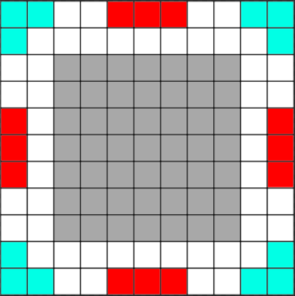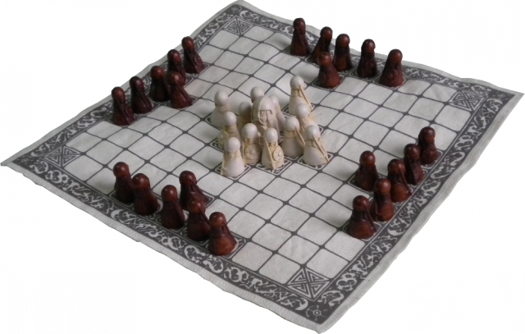With these new rules the players were far more engaged and lots of alliances, rivalries and strategies including ‘back stabbing’ were observed. Which is where the concept of a politically motivated game came from, specifically the America 2016 elections between Trump, Clinton, Sanders and other minor candidates (Times, 2016)**,** and the concepts for “Trump Escape” began to take form.

Figure Hnefatafl Board

Figure my iterations board

# Inspiration

During the development of Trump Escape, many game reviews were researched, and it soon became clear that few games received good reviews from everyone, therefore the idea of incorporating the best aspects from each game and its genre, to create a game for every type of player was conceived.

## Tom Clancy - games storytelling:

Three of the most popular Tom Clancy game series are; Ghost Recon, The Division and Rainbow, the reviews for which cite the storyline and gameplay as being the best part of this series.

With the exception of the Rainbow series these games are 3rd person, where the player is either alone playing as a super soldier saving America from civil war in The Division, or in a group of four trying to take down drug cartels or dictators in Ghost Recon.

These stories are vast and lengthy and if the player is engaged can be kept playing for long periods of time. To achieve this both game series have side missions and activities that players can complete for extra rewards and experience to level up there character.

Some of these missions relate to the main story, some are given to the player through discovery or free roam and others are earned by completing missions or tasks set by allies.

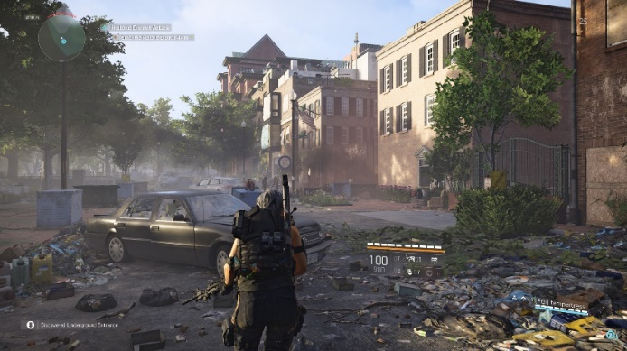All of which is designed to keep the players engaged with the game as well as the storyline.

Figure Player view

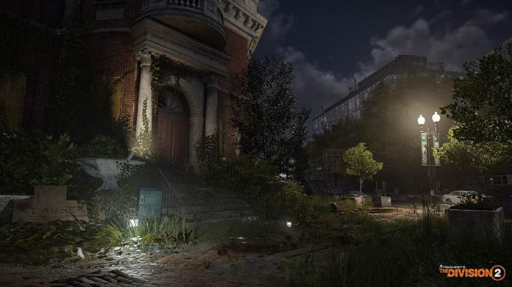Figures 3 & 4 depict the scenery and player view from Division 2 (Seagrave, 2019)**.**

Figure Scenery

## Farming simulator customisation

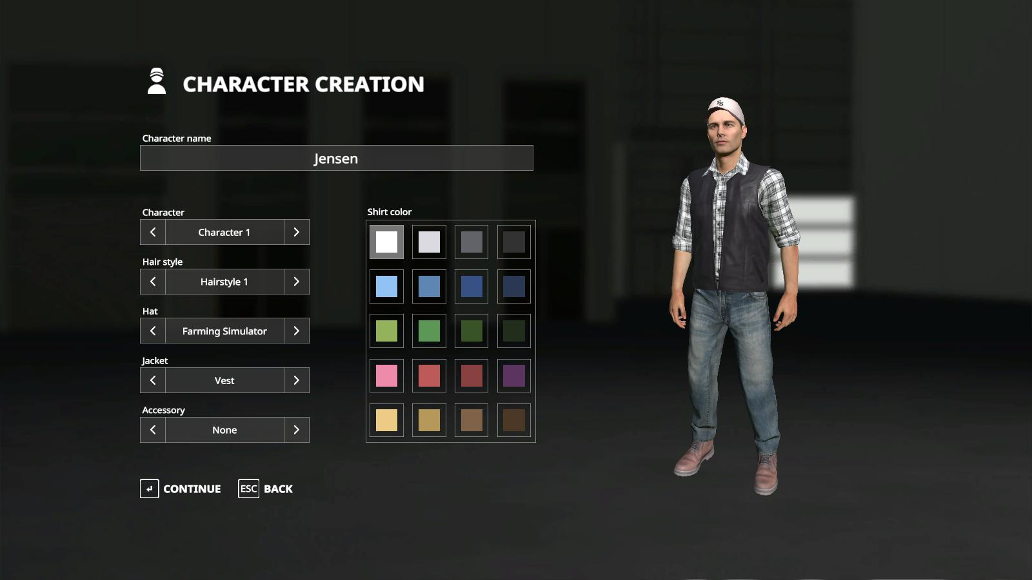This game has been a major hit with players around the world, due to its simplicity, relaxing influence and the requirement to use management skills. The feature that was most influential on Trump Escape was the simple and clear process to change the characteristics of an avatar (Joosse, 2014)**.**

Figure Option to select and customise character

## GTA V customisation options

This game has had extremely high reviews from players of all kinds due to its gameplay, story, customisation and open world features such as killing anything and anyone such as police, soldiers and the public. There’s also a lot of drug related crime in this game which may encourages players to engage in these actions safely rather than getting in trouble in the real world.

The two feature from this game series that stand out are the free roam features(Arsenal, 2018) and high character customisation options for the player (Logics, 2013)**.**

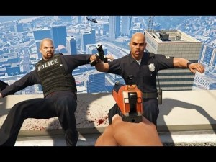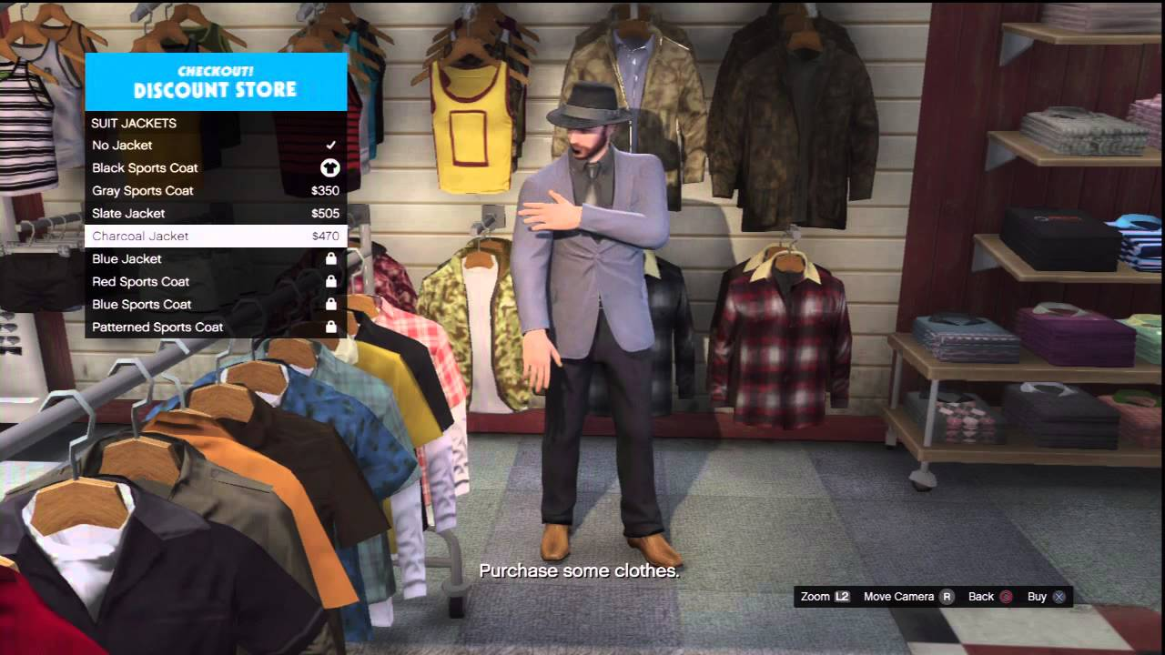Replicating this in Trump Escape, will allow players to create highly detailed characters, or if they wish just make their character look funny, and for those who are less interested in the storyline and just want some escapism, the free roam features will allow those players to go out and kill “stuff” animals, people or police just because they can. This is shown in figures 6 & 7 below.

Figure Random killing

Figure Detailed customisation

## HALO 3 ODST discovery system

Halo 3 ODST from the Halo series is based on a human alien war in the 26th century. The ODST (Orbital Shock Drop Trooper) spin off from Halo 3 has varied the game so the player is a human rather than a Spartan super soldier. The idea of this was to make players feel more vulnerable as enemy forces are far superior requiring players to be more strategic during gameplay.

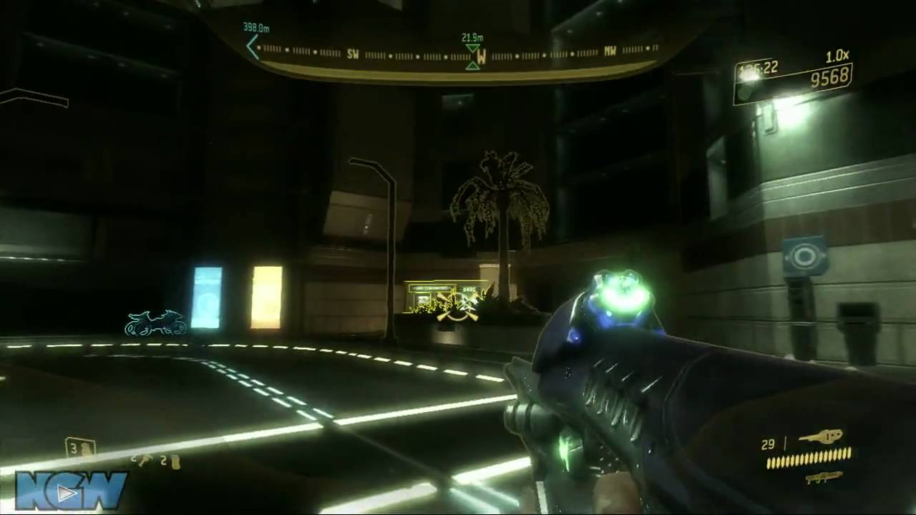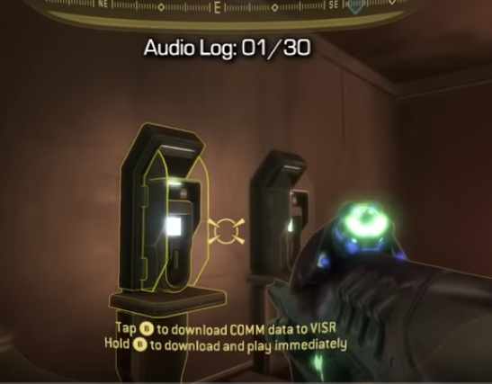How players discover collectables in this game, has influenced the similar feature in Trump Escape, with a distinct clear colour block, indicating the objects location, as well as an audible ringing which gets louder and clearer as the player gets closer, and vice versa as they move further away (Productions, 2015). Examples of this are shown in figures 8 and 9

Figure Colour block

Figure Audio indicator

## NFS Carbon territory gaining and rewards:

Need For Speed Carbon is a racing game where the player has to complete races of different kinds and by winning the majority of those races they capture the territory in question, along with extra rewards such as cars, visuals and respect. As they win more territories or zones and eventually capture them all the boss/ leader challenges the player to a series of races to win total control, after which they move onto the next area and so on.

However, this works both ways in that other minor factions as well as the main factions can win races in a zone already completed and capturing the territory. This removes the rewards previously earned by the player.

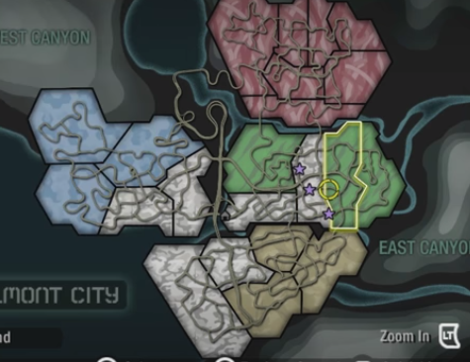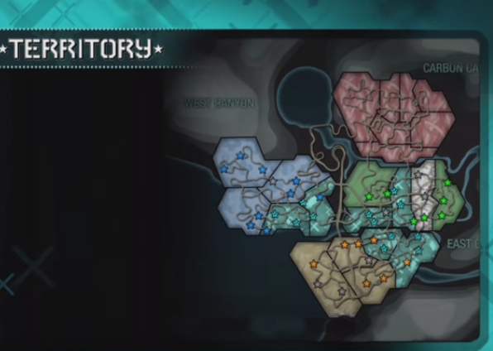This system explanation is shown on figures 10 & 11 between 18:44 to 19:10 (Riot, 2018)

Figure territory capturing

Figure territory map

The element to replicate from this game is the zone, territory capture system, replacing it with towns, regions and states with activities and side missions the player will need to complete.

Also replicating the risk of completed zones being won back by others, is an element that will work well in Trump Escape, as preventing the loss of territory already won will require strategy, otherwise it will become a distraction and prevent the successful completion of the game.

## Recent political events

One of the main inspirations to create this game has been the American political situation, which since the 2016 election, has been in the news almost daily, with never before seen Tweets from a president, with accusations and counter accusations on all sorts of subjects, which has basically led to a far higher visibility and opinions of politics in general.

Also there are not many, if any, 3rd person role playing game where the characters are current political figures.

# Starting points

Once the project brief was received, work started on the layout of the Game Design Document (GDD), using the recommended 10 page appendix supplied. Supplementing each section with personal notes on what to write and how to write it. These notes and bullet points prompted the progress of the report whilst also assuring it did not stray off topic.

The sections included a title page, the target market/ audience, game outline which briefly explains the story and the game flow including progression and reward systems, the characters in the game, gameplay including the storyline(s) and winning requirements, player experiences, and mechanics used, enemy’s encountered, multiplayer involvement, in game stores and finally monetization.

All of which required research at the beginning and during the development of the game.

# Evolution/ Development

## Interim Presentation

This presentation was an opportunity to show other developers and lecturers the intended game ideas, future development, the reasoning behind this idea, and the intended target market. This also helped the audience understand the game and what was required in order to win.

### Summary of America Down Under:

When the player first starts the game they watch a backstory scene of Donald Trump during a period prior to impeachment. His enemies find proof of his abuse of power, consisting of paperwork and witnesses who are willing to testify that he used the Russians to help win the 2016 election. He doesn’t believe them forcing them to release the evidence to the world, which is where the game starts.

The player starts in Washington DC at the White House as Donald Trump defending it from unknown enemy forces. In this opening mission the players are introduced to the basic movement and shooting mechanics in order to kill the enemy forces. They are then introduced to the throwing and communication mechanics. Once the mission is nearing completion they are introduced to the first collectable showing the player where Donald’s enemies are stationed.

### Feedback from presentation:

* Include audio, such as voices from characters, music in situations and sounds such as explosions and bullets.
* Have small pauses during the presentation so listeners can keep up
* Include small videos of gameplay such as the main mechanics and the level creations.
* Include current games that have similar game mechanics, aesthetics and inspiration
* Include a slide on in game purchases such as DLC and loot boxes to bring in more revenue.
* Represent game and sub game loops
* Make presentation background relatable to the game idea

### Feedback from gameplay

* Have the player play in first person so they don't know who their character is until they find a reflective surface
* Include an multi-choice option, so players can choose to play as other political characters, such as, Trump, Clinton or Obama
* Include dramatic music, to raise suspense
* Have an audio system to inform the player that something (good or bad) is close.
* Have more cut scenes during gameplay, scenarios such as being killed or killing a major enemy
* Add balance to the game, by including both good and bad character traits

The feedback received was generally good, the main criticism was the lack of character choice and the story line. So it to address this features were added to allow players to choose to play as Trump, Clinton or Obama. With all three characters having positive and negative traits and buffs. Each characters then has a variation of the story line, with different goals and methods to achieve them. Whilst retaining the opportunity for a player to kill off the opposing candidates during gameplay.

## Progression chart development

A progression chart was created based on the original storyline, and included the events that might occur during gameplay or endgames plus potential DLC.

### First iteration:

The first version of the progression chart focussed on the game content and storyline over layout and neatness. Using an A4 piece of plain white paper, the gameplay was mapped out and updated based on the feedback from the interim project presentation. As a result the main gameplay actions and player choices are represented on the chart with the “yes” and “no” options having immediate effects. Figure (12)

Figure Progress Chart 1st Iteration

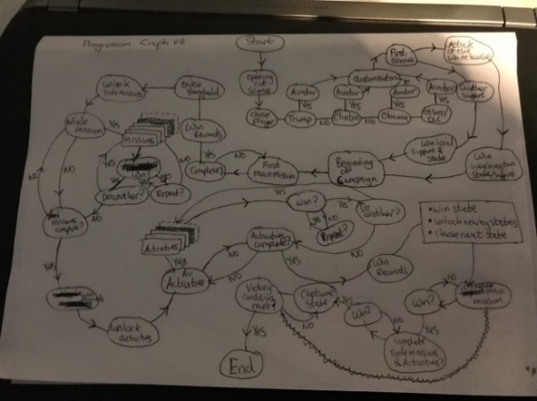

### Second iteration:

The second version includes the downloadable content (DLC) options, that the player can purchase and where they can use them. For example DLC characters, customisations, missions and scenarios. Also the graphics on the chart related to their content e.g. a circle is a process and multiple boxes mean multiple choices for the player. Figure (13)

Figure Progress Chart 2nd Iteration

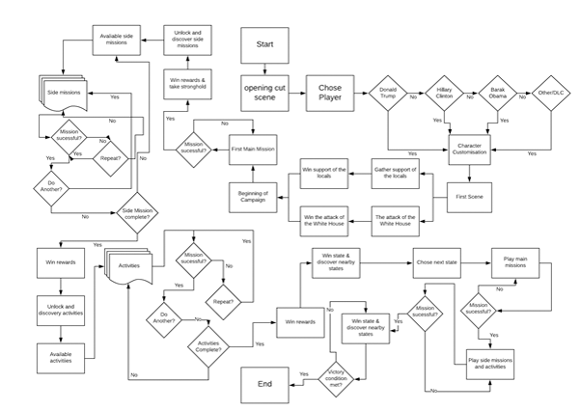Third iteration:

In the third iteration, “Lucidchart” was used in order to create a neat drawing that could be edited dynamically. **(Link 12).** This program made it easier to see the flow of the gameplay, with again specific geometric shapes representing each action; rectangle for a process, diamond for a question and stacked quadrilaterals for multiple choices. Figure (14), larger image Appendix A

Figure Lucid chart 3rd Iteration

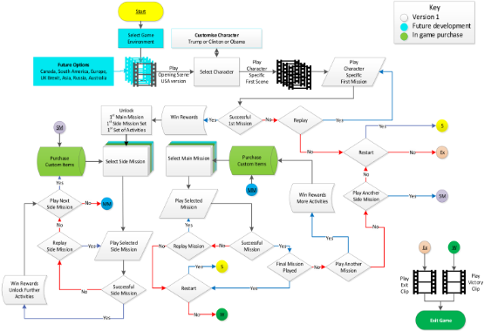Fourth iteration:

The “Lucidchart” was very crowded and somewhat hard to follow, so after some research “Microsoft Visio” was used to recreate the process. This program has specific workflow tools and enabled the use of colour and non-geometric images. Allowing the use of video icons for cut scenes, a key with colours for the reader to follow and understand and also ‘on sheet links’ to declutter the chart. Figure (15) larger image Appendix B

Figure Visio, 4th Iteration

# Game Icons:

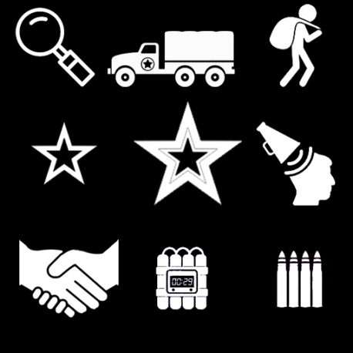Below are the game icons that will assist the player to know what missions and activities they’ll be attempting and the rewards they can potentially earn.

### Mission & Activity:

These icons, represent mission types, activities and actions>

The top row, represent discovery and information gathering, hijacking an enemy convoy and looting abandoned areas.

The middle row, represent side, main story and propaganda missions. The last row, represent negotiations, timed explosive and ammo replenishment missions. Figure 16.

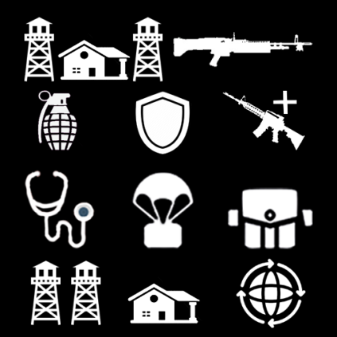

Figure Missions & Activities

### Locations and character traits:

These icons represent places of interest, which may warrant investigating to collect rewards or resources. The top row represent stronghold locations and light machine guns. The next row represents explosives, armouries and hidden weapons cache locations. The next row are hospital locations where health can be obtained, weapons air drop and appearance locations.   
The final row are fortified areas of interest, safe houses and international negotiations safe zones. These become accessible during discovery and negotiation missions. Figure 17.

Figure Locations and Traits

### Health Variations:

These icons represent health options the player can use, upgrade and equip.

The top row, represents, health usage reloading, sharing health with allies and a loot able health kit.

The middle row, represents, health packs, upgrades for effective health usage and adrenaline.

The final row, represents, forging for health packs, drugs and injections. Figure 18.

Figure Health Varations

### Weapons

These icons represent the types of weapons players have available to them on the selection screens, mission rewards and at lootable locations. Figure 19.

## Inspiration

To create these icons some of the designs from The Division 2 (Cheung, 2019) and Wildlands (Gur, 2018) were replicated, while some were designed specifically for this game.

Figure Weapons

# Game Logos:

## Title Logos:

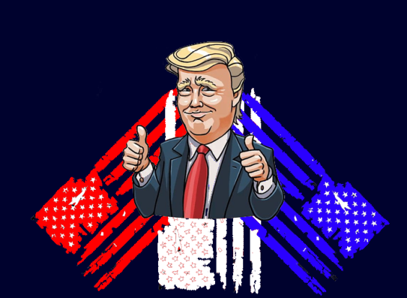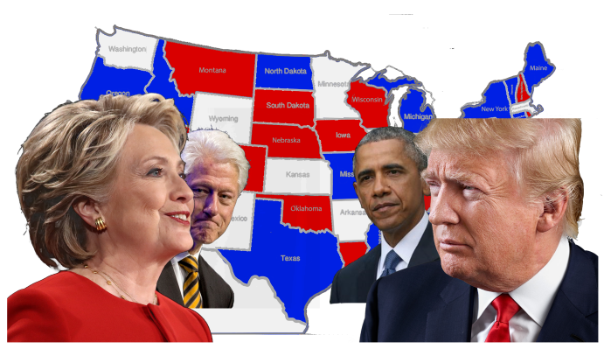The image in Figure 20 is both the game case and main menu logo for the console platform.

It features all the main characters, both Clintons (Aleem, 2015, Lakoff, 2016) Trump (Scherer, 2015), and Obama (Wagner, Hayes and Rocha, 2019), having a face off across a map of America. The map is behind the characters to create the impression of the battleground for the game.

The logo on the right Figure 21 is App game logo, for both the Apple or Android stores.

It features Donald Trump with his thumbs up (Link 19) and three American flags behind him. This is designed to draw players who are into mobile game, and is currently a work in progress.

Figure Mobile App cover

Figure Console Game Cover

le App

## Faction Logos:

### Donald Trump

This logo will represent Donald Trump’s faction. It shows him with his thumbs up (Moh48, 2017), in front of two American flags. Some of the state represented by a star are missing due to his belief that these states are relatively minor to him. His slogan “make America great again” is from his 2016 election slogan campaign, and shows he thinks his methods are correct. Figure 22.

Figure Donald Trump

### Hillary Clinton:

This logo will representing the Clintons’ faction. On the front there’s a photo of Hillary holding a pistol and aiming straight towards the viewer (Stuart, 2007), whist Bill is hiding behind her. This is designed to intimidate her opponents, as does her slogan, “keep calm it’s my turn” which suggests whatever happens she will be the next president.

Figure The Clintons

### Barack Obama:

Figure The Obamas

This logo will represent the Obamas’ faction. The flag shows a half and half image of Barack and Michelle, representing equality of gender and colour. Their slogan “Save our Country” is aimed at appealing to those who have suffered and wish to stop their country being torn apart by politics. The secondary slogan is their promise of a better future.

# Game Map and Features

## Map

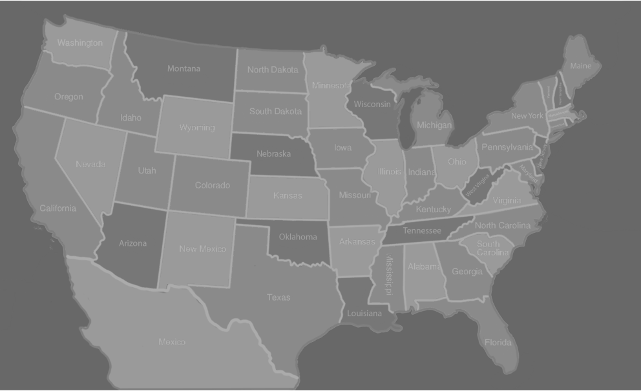This game map is where the player will be located during gameplay (Bogle, 2012). Their objective is to navigate their way from state to state, completing missions and activities to progress. They will be unable to enter the next city or state until they have successfully completed that “levels” main story missions. The only player who can enter Mexico is Donald Trump and only if they have chosen to play the escape storyline. Figure 25.

Figure Game Map of USA and Mexico

## City Representation

On the game map there are also cities where the player can complete side missions and activities to capture and win rewards. Control of each cities boosts the influence in the state, so the player can progress and win further rewards.

The cities included in the game will be the capitals of each state as well as any with iconic landmarks (Barber, 2017) or buildings owned by the character (Pierce 2019) such as the trump towers. Figure 26.



Figure 26 City Views

This allows for additional cities to be added, by game pack uploads at a future date.

# Artefact:

As part of this module a playable prototype as well as any created or downloaded assets will be provided. The diagrams, storyline and moodboards will be used as a guide for this, whilst the preferred software and game engines will be used to show a video presentation of the game.

Below are all the clothing artefacts created using Autodesk Maya 2019, these models will be imported into a game engine and included in the character customisation screen so players can select an item and include it on the character they’ve selected.

There are also models downloaded from 3D model sites such as SketchFab and Turbosquid to help fill in the options unable to be completed manually.

### Head customisation

In the game there are head model assets such as a variation of hats the player can select in the customisation menu. The asset was created on Autodesk Maya 2019 using the methods of extruding, scale, connect, soft selection and smoothing tools.

Using these given tools, the models created where; snapback cap, tweed brim hat, and felt hat.

Reference images were used with rotation options guide line videos and photos to create these assets. For the cap (KG, A 2020) and felt hat (Hat, 2019) and video (Palmucci, 2014), static images and finally a physical tweed hat were used as references to complete these models. The first GIF below will show them all. Figure 27



Figure 27 Example Head Assets

### Face customisation

The next category of assets are face models, specifically different variation of glasses the player has access to in the customisation screen.

They were created using the same tools as the hats as well as being smoothed in certain sections rather than the whole object, but with the addition of using the mirror tool to save time, avoid illegal polys and being perfectly symmetric.

A variety of different guide videos and reference images were used to complete these models, the first pair was created using (Gabbana, 2016) images, the second using (Morris, 2020), the third using (Stash, 2019) and the last using (Timepieces, 2019) and then adding several holes in the middle. The second GIF will show them all. Figure 28



Figure 28 Example of Face Assets

### Upper & lower body customisation

The next category of assets are the upper and lower body models which the player has access to in the customisation screen. They were created using the same tools previously specified but this time using the soft selection tool, and curving a lot of the hard edges in order to add fabric creases and folds to the models. Examples are shown below in figures 29, and the third GIF link shows them all.

Again a variety of videos were used help guide the process to create these models, however some models proved to be to more challenging than others, requiring downloaded from Sketchfab and Turbosquid online free 3D models library to fill in the models required. These included shirts (eigenscene, 2016), jumpers (BUBEN, 2010), dresses (Dechev, 2009, Shvets, 2014) and trousers (chemise, 2019). The fourth GIF will show them all.

Figure 29 Examples of Body Assets

### Footwear Customisation

The final assets are the footwear models which the player will have access to in the customisation menu. They were created using all the methods and tools previously stated as well as the mirror and bridge tools in order to keep things symmetric. Some sample models were downloaded off the internet and then edited, reducing the amount of faces as well as incorporating parts from previous models being implemented.

3D model websites such as Sketchfab were used to help create these models as well as to receive footwear models, to save time (DeMoon, 2018). Examples shown in figure 30 and the fifth GIF link shows all the current models.



Figure 30 Examples of Footwear Assets

## Characters

For this module it’s required to create playable characters (PC’s) and non-playable characters (NPC’s) for the player to select, customise and interact with, or against, opposing NPC’s. To create these characters with a realistic style would prove to be a major challenge.

### Adobe Fuse Development

Whist researching into methods to create realistic characters a video (Learning Hub and Tutorials, 2017) was discovered, which described an app called Fuse created by Adobe, which lets a user build realistic characters using a vast number of customisations.

The user first assembles the character by selecting options for the head, torso, arm and legs, then they have the option to customise these body segments, even down the details like teeth and facial features.

Clothing is then selected, from a vast array, or the user can import their own 3D creations instead.

Lastly there’s the options to change the colours and patterns on these clothing assets.

Below in figure 31, are images of these process, and a few of the completed characters that are possible using just the default settings.



Figure 31 Options and Sample Figures from Adobe Fuse

### GIF links to Models

<https://media.giphy.com/media/VEVSd6u6W72EZqqzcs/giphy.gif>

<https://media.giphy.com/media/LnLW06jY0YrHGIi00E/giphy.gif>

<https://media.giphy.com/media/VJrt7kVjPHo6t8a48R/giphy.gif>

<https://media.giphy.com/media/cM3Ddd3IvXeHg7tTbu/giphy.gif>

<https://media.giphy.com/media/ZFK3W7PapdnG32AW17/giphy.gif>

# Future Development

### Create variation icons:

Player HUD icons have been created which relate to, the usage of health and the distribution of it.

A future option would include HUD icons, for the use of weapons, such as ammo and reloading icons, armour effectiveness or health, different types of explosives such as C4 and TNT, which the player can select to use.

Lastly negotiation icons would be created, where responses are related to the inputs from the player, the circumstances of the game, and the group being negotiated with.

### Create city landmark locations:

On the game campaign map there’s currently no indication of where state capitals or iconic buildings, areas, or cities are placed, which makes winning support from an entire state more difficult than intended.

To correct this, small white stars will be added to the map to indicate the state capital, and for iconic buildings and areas, a 2.5D form will be placed on the map, within each state or city depending on where they are located.

### Logo Iterations

Feedback received, suggests the console case title logo looks too much like an election campaign logo and does not give the impression of a civil war, destructive and power taking role playing game.

In order to create an excellent, memorable and appropriate logo design, research will be carried out into logo methodology (Kolowich, 2019), how to create a games logo which is unique and not standard or boring (Calvin, 2018), and logo creation techniques (French, 2016). After which a new case logo will be produced.

### More customisation options

The current character customisation options available to the player are minimal, resulting in reduced variance in character design, so additional 3D clothing and accessories, such as earrings, suitcases and backpacks will be designed and added to the available options. As well as a greater range of colours, textures and patterns allowing greater customisation of assets. This will allow the player to customise more than just the clothing of their character.

### Game engine menu screens

It’s intended to implement the character customisation options create on Adobe Fuse onto Epic Games Unreal 4 game engine with the main menu and character selection screens required to reach the customisation screen.

Video guide (Learning Hub and Tutorials, 2016) will be used as a reminder of the menu creation process and (Ward, 2016) to create the customisation screen for the player.

### Introductory levels

First introductory level for all three playable characters, Trump, Clinton and Obama, will be added.

Trump and Clinton’s first level will start be at the White House, with the player who selected Donald defending the White House, whist learning all the basic mechanics required to progress through to the game map. Whilst the player who selects Clinton will start as a militia soldier attacking the White House whist learning all the mechanics.

The Obama character will be playing a different style of game gathering influence and support in his local state, learning the negotiation mechanics, this will be more of a strategic game play, but will still include elements of battle.

# Outcome

During the process of this assignment and module I have learned a lot of new skills, gained experience of new tools and programs, resulting in positive progress and experience in games creation.

### Story telling skills

This module has afforded me the opportunity to stretch the limits of my imagination, in order to create a highly detailed storyline, based on factual events, which is difficult to give justice to with the word count constraints in the past. The end result of three storylines, one for each main playable character, where each has their advantages and disadvantages, which evolve further throughout the gameplay, giving the player a vast number of choices to make. Which is what makes a great role playing game.

### Completing assets and characters

The freedom of choice of what software to use has been a great opportunity to learn new methods and to understand alternative asset and character creating software.

When the course started I had little experience with realistic and organic modelling methods, which I thought might be a problem, however with the introduction of Adobe Fuse I have been able to use my creativity to assemble and customise characters from scratch. Whilst at the same time learning how to create detailed clothing assets, which had added to my list of skills.

The introduction to Autodesk Maya 2019 has helped me even further, due to its modelling methodology being superior to Autodesk 3DS Max which is what I have used in the past.

### Feedback and Reactions

During the presentations my audience loved the idea of a 3rd person role playing game based on a near future America, with the prologue and opening cut scenes being very relatable to real world events. Follow up conversations with my fellow students, confirmed that everyone found the game concept very entertaining and funny, with great potential for a success in the future.

The customisation menu options were especially highly complemented, as they gave the player the opportunity to create crazy, funny or standard outfits for very well-known politicians, as playable characters.

### What did I want to achieve with my prototype?

I successfully created a character customisation menu as well as the gameplay map, all the 2D icons, most of the HUD icons, faction logos, clothing assets and character designs. What I also wanted to achieve was to include all these assets, customisation screens and gameplay map with icons into Epic Games Unreal 4 games engine, simply to provide the evidence of what the game would look like when played. I have plans to do so with the help of (link 44) to provide this.

# Conclusion

During this project I was given the freedom of choice on what I wanted to present come deadline day, as well as the opportunity to learn, new software programs which support my design requirements, all of which helped me reach these goals.

I have learned several new software programs including, Adobe Fuse to create characters, Autodesk Maya to create assets and Microsoft Visio to create diagrams and progression (flow) charts.

This has been a massive challenge for me but it has also presented the opportunity to build on the skillset I came into the course with.

# Appendixes

## A: Lucid Chart

## B: Visio Chart

